FOR IMMEDIATE RELEASE

Contact:
Liz Orton
orton@canceriowa.org
319-467-4569

New Iowa Cancer Consortium Board Members Aim to Use Their Passions to Help Reduce Iowa’s Growing Cancer Rates

CORALVILLE, IA – July 11, 2024 – The Iowa Cancer Consortium is pleased to announce the addition of two new board members, Morgan Newman, MSW (Norwalk, IA) and Devon Gurnett, MSOM (Des Moines, IA).

With Iowa second-in-the-nation for cancer incidence rates for the second year in a row (behind only Kentucky), the Iowa Cancer Consortium has seen unprecedented growth in the number of passionate survivors, caregivers, researchers, healthcare professionals, and others joining together to reduce the burden of cancer in the state. Membership in the Iowa Cancer Consortium, Iowa’s comprehensive cancer control coalition funded in part by the state and the CDC, has increased 39% in the last three years. And for the board of directors’ election for the 2024-2026 term, more candidates than ever expressed their desire to help lead the Consortium into its third decade.

For new board members Morgan Newman and Devon Gurnett, the Iowa Cancer Consortium–and cancer itself—is not a new territory.

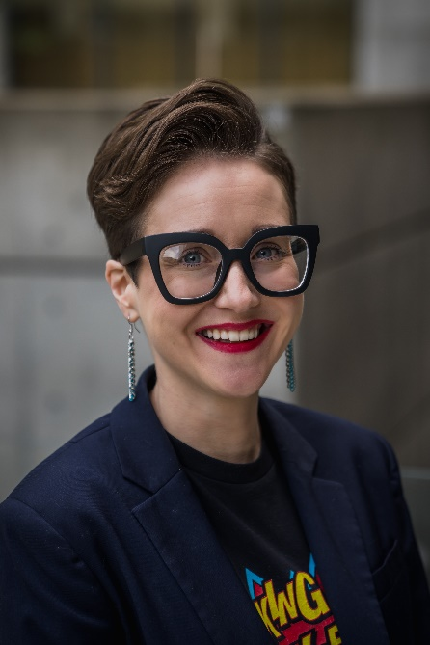
Morgan Newman, MSW (Norwalk, IA)

Morgan Newman joined the Iowa Cancer Consortium five years ago. A resilient cancer survivor, social worker, and dedicated patient advocate – Newman overcame metastatic and recurrent cervical cancer at the age of 24. Since then, she has devoted herself to making a meaningful impact.

As a Cervivor Ambassador with Cervivor, Inc., Newman openly shares her experience with cervical cancer and her regret of not getting the human papillomavirus (HPV) vaccine when it was offered to her, which could have prevented her form of cancer. She also emphasizes that the effects of cancer do not end when treatment ends – many cancer survivors live with the side effects of chemotherapy, radiation, and surgery long after treatment concludes.

Newman has served as a patient advocate on the National Institutes of Health’s Enduring Guidelines and Extended Genotyping Panels, as well as the National Cancer Institute’s Patient Advocacy Steering Committee and Cervical Task Force. She works as the Community Engagement Liaison at Cervivor, Inc., and is a member of the Board of Directors for Above + Beyond Cancer. She also serves as Iowa State Lead Ambassador for the American Cancer Society Cancer Action Network (ACS CAN).

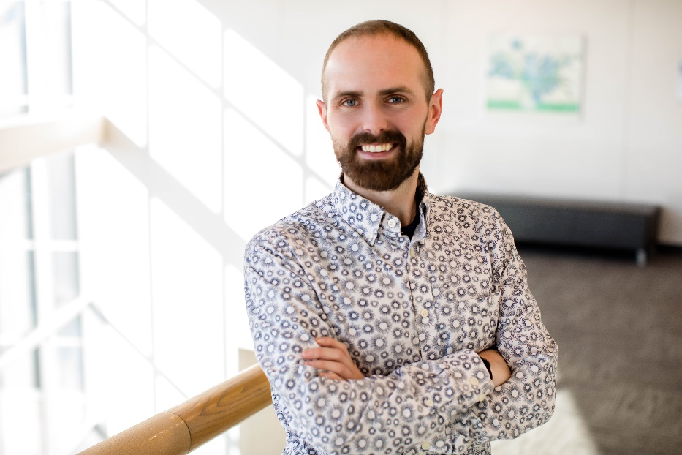
Devon Gurnett, MSOM (Des Moines, IA)

Devon Gurnett has been a member of the Iowa Cancer Consortium for four years and currently works as a Program Manager for the Iowa Primary Care Association (Iowa PCA), a non-profit that provides technical assistance and training to Iowa’s 14 Federally Qualified Health Centers (FQHC’s).

Gurnett leads the Colorectal Cancer Screening Grant at Iowa PCA, which works to increase colorectal cancer screening rates within under-resourced and uninsured populations, in collaboration with FQHC’s throughout Iowa and the Iowa Department of Health and Human Services.

Gurnett’s passion lies in addressing patient barriers and challenges associated with screening, and he places a strong emphasis on collaboration and partnerships to develop effective solutions. Ultimately, his focus is on promoting health equity for all and enhancing access to screenings as part of collective efforts to improve community health.

“We are excited to have Morgan and Devon join the board during this time when it is critical for Iowans to confront what is happening here with our cancer rate,” said Mary Charlton, PhD, board president of the Iowa Cancer Consortium. “It will take many dedicated people with an array of expertise to help understand and address Iowa’s high cancer rates – and the Iowa Cancer Consortium plays an important role in bringing those people together and gathering them around evidence-based strategies outlined in the Iowa Cancer Plan. Morgan’s focus on advocacy and survivorship and Devon’s drive for health equity and access to care will be great assets on our board.”

The Consortium also welcomes back four board members who were re-elected to the Board of Directors for the 2024-2026 term.

- Mary Charlton, PhD (Iowa City, IA) was re-elected as board president. Dr. Charlton is a Professor of Epidemiology at the University of Iowa College of Public Health and the Director and Principal Investigator at the Iowa Cancer Registry.
- Richard Deming, MD (Des Moines, IA) was re-elected as board vice-president. Dr. Deming is the Medical Director of MercyOne Richard Deming Cancer Center and the Founder of Above + Beyond Cancer.
- George Weiner, MD (Iowa City, IA), was re-elected as an at-large board member. Dr. Weiner is a Hematologist and Director Emeritus at the University of Iowa Holden Comprehensive Cancer Center.
- Cindy Fiester, MSN (Cedar Rapids, IA) was re-elected as an at-large board member. Ms. Fiester is a Chronic Disease Services Coordinator and Registered Nurse at Linn County Public Health.

The newly elected and re-elected board members join other esteemed members:

- Treasurer - Christen Sewell, MHA (Fort Dodge, IA), Director of Public Health for Humboldt County
- Secretary - Georgia Hodge, CHW (Waterloo, IA), breast cancer survivor and founder of F.R.I.E.N.D.S.
- David Dickens, MD (Iowa City, IA), Clinical Director of Pediatric Cancer Services at University of Iowa Stead Family Children’s Hospital
- Rudy Papakee, MHA (Tama, IA) Director of the Meskwaki Tribal Health Center
- Sneha Phadke, DO, MPH (Iowa City, IA) Associate Professor and Breast Medical Oncologist at the University of Iowa Holden Comprehensive Cancer Center
- Maria Torres (Council Bluffs, IA) Health Equity Coordinator for Pottawattamie County Public Health
- Sarah Zeidler, FACHE (Des Moines, IA) Executive Director of Oncology Services at UnityPoint Health- John Stoddard Cancer Center

For more information about the Iowa Cancer Consortium, its initiatives, or the new board members, please visit www.canceriowa.org.

###

About the Iowa Cancer Consortium
The Iowa Cancer Consortium is Iowa’s statewide comprehensive cancer coalition. As a leader in cancer control, the Iowa Cancer Consortium offers the state’s key cancer partners access to resources, expertise, and non-competitive collaboration across traditional boundaries for a bigger impact in cancer prevention, early detection, treatment, quality of life, and health equity. Learn more at www.canceriowa.org.

