Cancer Clinical Trials in Iowa Messages

Dear Cancer Control Partners:

The Iowa Cancer Consortium is dedicated to bringing you, our cancer control partners, timely and credible cancer information to share with your community.

In the pages to follow, you will find a series of social media messages, explaining and promoting the Cancer Clinical Trials webpage from canceriowa.org. This web page includes a comprehensive list of where to find cancer clinical trials in the state and where to learn more about the importance of trials. Images produced by the Iowa Cancer Consortium are provided in Canva templates. Any image with the Consortium’s logo can be opened and downloaded from Canva. Feel free to add your organization’s logo in the space next to the Consortium’s logo.
Our hope is that you will find these messages useful as we work to reduce the burden of cancer in Iowa … together!

If you have specific questions or would like to learn more, please contact Abby Batterson, Communications Coordinator at batterson@canceriowa.org.

Cancer Clinical Trials in Iowa
For additional resources, visit: https://canceriowa.org/resources/clinical-trials/
Message | Suggested Image  (Click image to open and save)
Are you interested in learning more about cancer clinical trials in Iowa?  Visit canceriowa.news/clinicaltrials to see what options are available. | 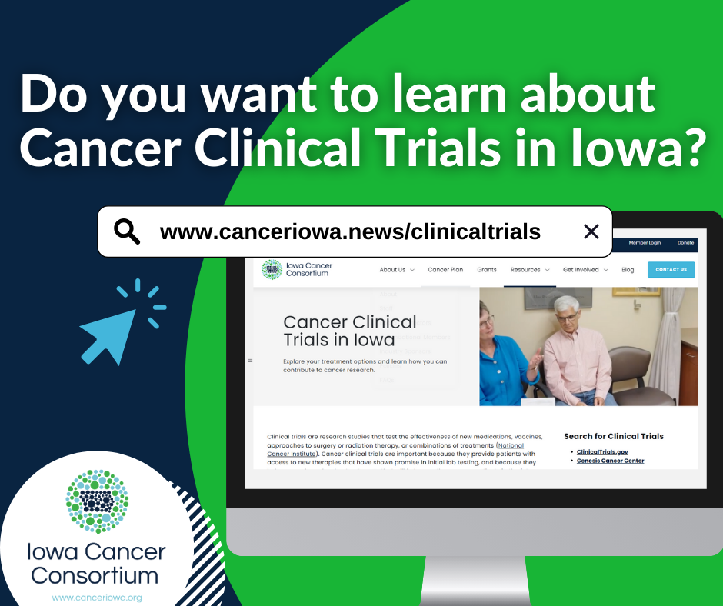
The Cancer Clinical Trials webpage features a complete list of where to find clinical trials in Iowa! Members of the Iowa Cancer Consortium worked hard to put them all in one place for ease. Take a look! canceriowa.news/clinicaltrials | 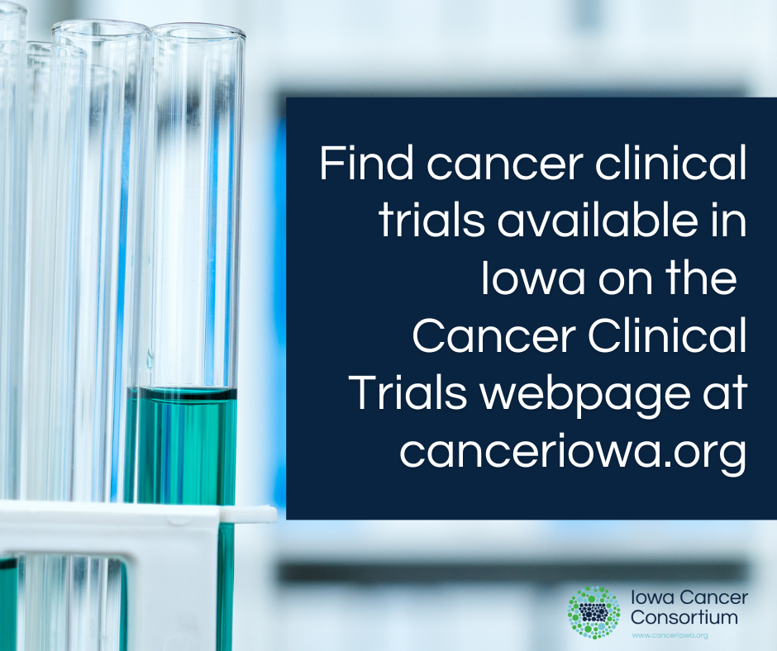
Clinical trials are research studies that test the effectiveness of new medications, vaccines, approaches to surgery or radiation therapy, or combinations of treatments (National Cancer Institute). canceriowa.news/clinicaltrials | 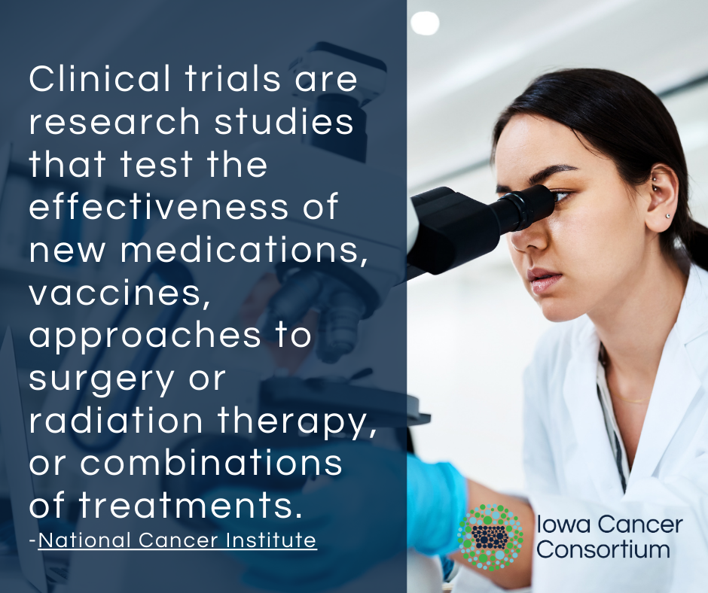  Alternative Image  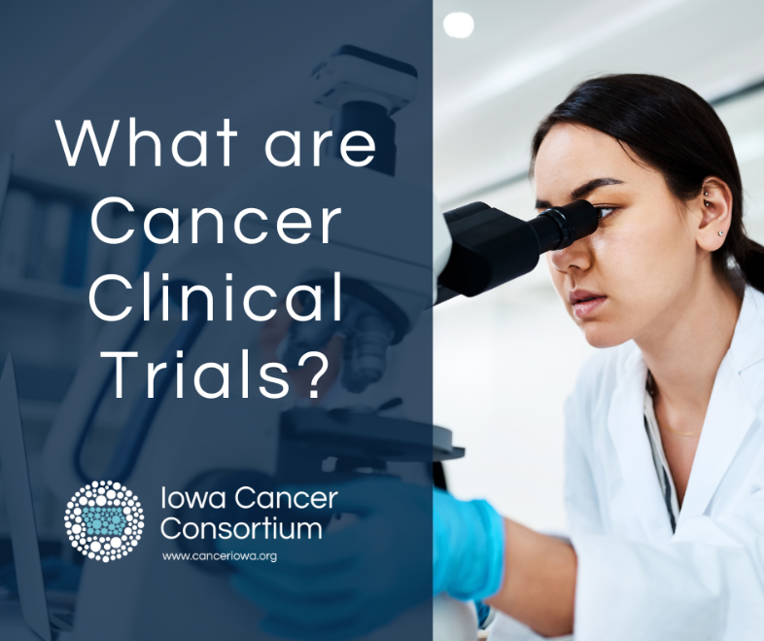
Cancer clinical trials are important because they provide patients with access to new therapies that have shown promise in initial lab testing, and because they help researchers develop treatments that will benefit countless cancer patients in the future if they are found to be successful. canceriowa.news/clinicaltrials | 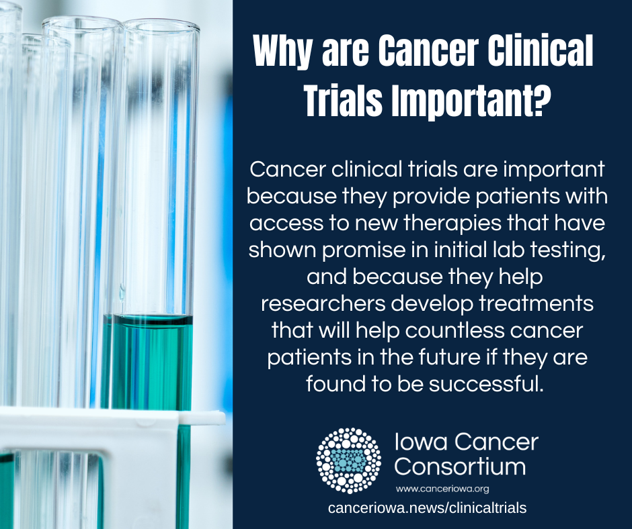
Talk to your doctor about your options with clinical trials. canceriowa.news/clinicaltrials can help you find cancer clinical trials in Iowa that may be right for your cancer type and site. | 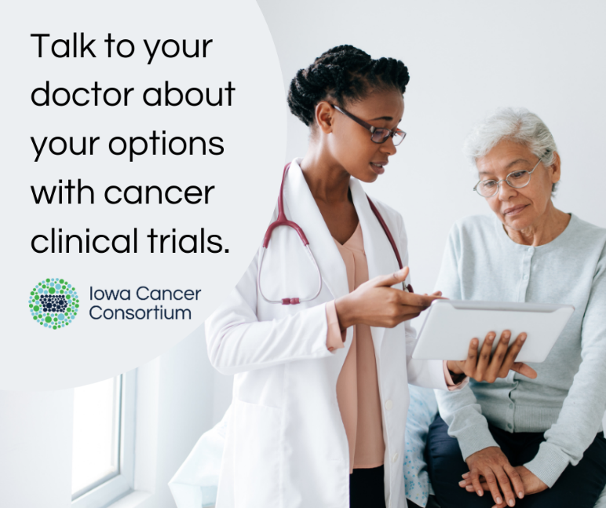
Learn how you can contribute to cancer research at the Iowa Cancer Consortium’s Cancer Clinical Trials in Iowa webpage. canceriowa.news/clinicaltrials

