FOR IMMEDIATE RELEASE

Contact:
Liz Orton
orton@canceriowa.org
319-467-4569

Iowa Cancer Consortium Announces Changes to Board of Directors

CORALVILLE, IA - September 8, 2023 - The Iowa Cancer Consortium is pleased to announce the addition of two new board members, Maria Torres (Council Bluffs, IA) and Sneha Phadke, DO, MPH (Iowa City, IA). Both bring with them a wealth of knowledge and a passion for advancing the Consortium's mission of advancing cancer prevention and control in Iowa through advocacy, equity, and collaboration.
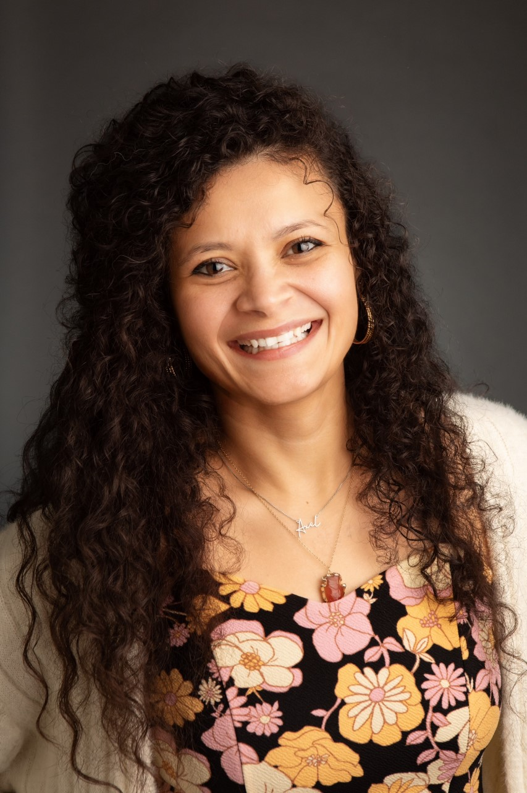
Maria Torres (Council Bluffs, IA)

Maria Torres is a native of El Salvador and moved to the United States with her family when she was 10. She currently works as the health equity coordinator for Pottawattamie County Public Health in Council Bluffs and believes in the importance of diverse representation and lived experiences. Having witnessed her grandmother’s struggle with cancer and the lack of resources available in Spanish, she is passionate about helping the Latino/a/x community access information and support.

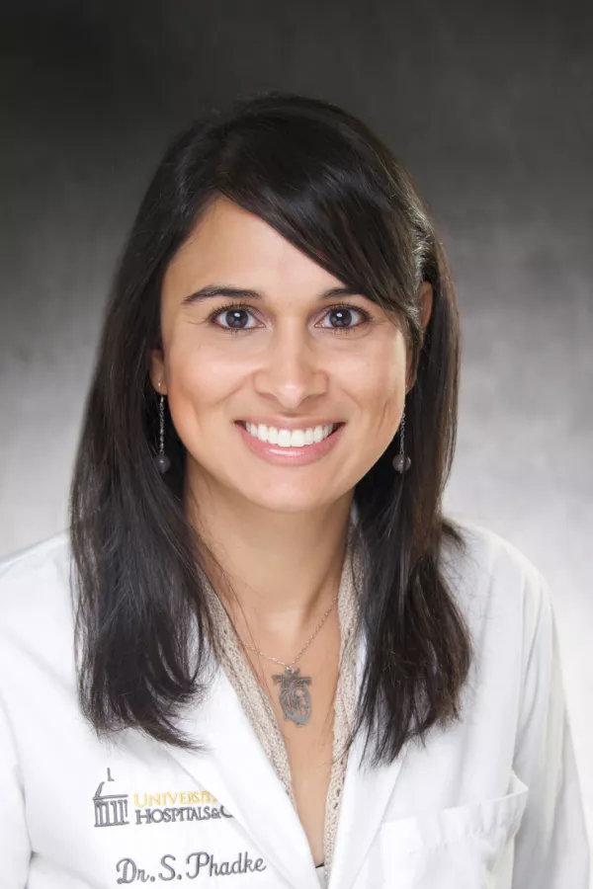
Sneha Phadke, DO, MPH (Iowa City, IA)

Sneha Phadke, DO, MPH, is an associate professor and breast medical oncologist at the University of Iowa Holden Comprehensive Cancer Center. In addition to patient care, she is the principal investigator for several breast cancer clinical trials at Holden and is involved in outcomes research, projects in outreach and community engagement, and studies aimed at interventions to improve quality of life for patients with cancer.

"We are incredibly fortunate to have both Maria and Sneha join our board," said Mary Charlton, PhD, president of the Iowa Cancer Consortium. "Their distinct backgrounds and complementary perspectives, combined with their shared dedication to reducing the burden of cancer, will undoubtedly drive our organization forward. We look forward to benefiting from their insights and leadership."

The Consortium also welcomes back five board members who were re-elected to the Board of Directors for the 2023-2025 term.

- Christen Sewell, MHA (Fort Dodge, IA) was re-elected as board treasurer. Ms. Sewell is the Director of Public Health for Humboldt County.
- Georgia Hodge, CHW (Waterloo, IA) was re-elected as board secretary. Ms. Hodge is a breast cancer survivor and founder of F.R.I.E.N.D.S.
- David Dickens, MD (Iowa City, IA) was re-elected as an at-large board member. Dr. Dickens is the Clinical Director of Pediatric Cancer Services at University of Iowa Stead Family Children’s Hospital.
- Rudy Papakee, MHA (Tama, IA) was re-elected as an at-large board member. Mr. Papakee is the director of the Meskwaki Tribal Health Center.
- Sarah Zeidler, FACHE (Des Moines, IA) was re-elected as an at-large board member. Ms. Zeidler is the Executive Director of Oncology Services at UnityPoint Health- John Stoddard Cancer Center.

The newly elected and re-elected board members join other esteemed members:

- President: Mary Charlton, PhD (Iowa City, IA), Professor of Epidemiology, University of Iowa College of Public Health; Director and Principal Investigator, Iowa Cancer Registry
- Vice President: Richard Deming, MD (Des Moines, IA), Medical Director of MercyOne Richard Deming Cancer Center; Founder, Above + Beyond Cancer
- Immediate Past President: George Weiner, MD (Iowa City, IA), Hematologist and Director Emeritus, University of Iowa Holden Comprehensive Cancer Center
- Cindy Fiester, MSN (Cedar Rapids, IA), Chronic Disease Services Coordinator and Registered Nurse, Linn County Public Health
- DeAntony Humm (Omaha, NE), Senior Director, National Accounts, Genentech
- Lori Pietig, MHA (Carroll, IA), Cancer Services Director, St. Anthony Regional Cancer Center
- Sara Ternes, MPH (Iowa City, IA), PhD student in the Epidemiology Department at the University of Iowa College of Public Health

For more information about the Iowa Cancer Consortium, its initiatives, or the new board members, please visit www.canceriowa.org.

###

About the Iowa Cancer Consortium
The Iowa Cancer Consortium is Iowa’s statewide comprehensive cancer coalition. As a leader in cancer control, the Iowa Cancer Consortium offers the state’s cancer stakeholders access to resources, expertise, and non-competitive collaboration across traditional boundaries for a bigger impact in cancer prevention, early detection, treatment, quality of life, and health equity. Learn more at www.canceriowa.org.

