For Immediate Release: 11-01-2022

Contact: Liz Orton, (319) 784-8814, orton@canceriowa.org

Iowans Honored for Work in Cancer Control

Almost 200 cancer professionals and advocates came together in Ankeny on October 25th for the annual Iowa Cancer Summit. Among them were the recipients of three awards, given out every year by the Iowa Cancer Consortium to people who have worked to reduce the burden of cancer in the state.

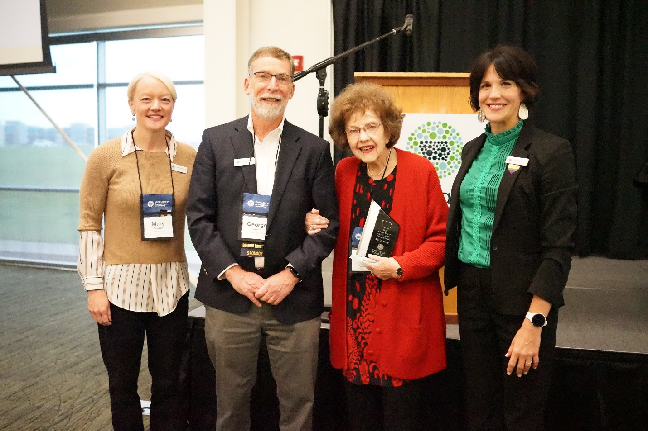
Shirley Ruedy accepts the George Weiner Cancer Control Visionary Award at the 2022 Iowa Cancer Summit. L-R: Dr. Mary Charlton (Iowa City), Dr. George Weiner (Iowa City), Shirley Ruedy (Cedar Rapids), Kelly Wells Sittig (Iowa Cancer Consortium executive director; North Liberty).

Retired Gazette columnist and three-time cancer survivor Shirley Ruedy accepted the inaugural George Weiner Cancer Control Visionary Award for her tireless efforts to raise awareness and share credible cancer advice in her bi-weekly column that ran for 16 years. After two different editors told her “No,” Mrs. Ruedy persisted and eventually published over 400 columns relating to cancer. Through her writing, which has been compiled in a book titled “Finally, A Manual on How to Handle Cancer,” Mrs. Ruedy no doubt saved hundreds of lives by encouraging readers to get screened for cancer.

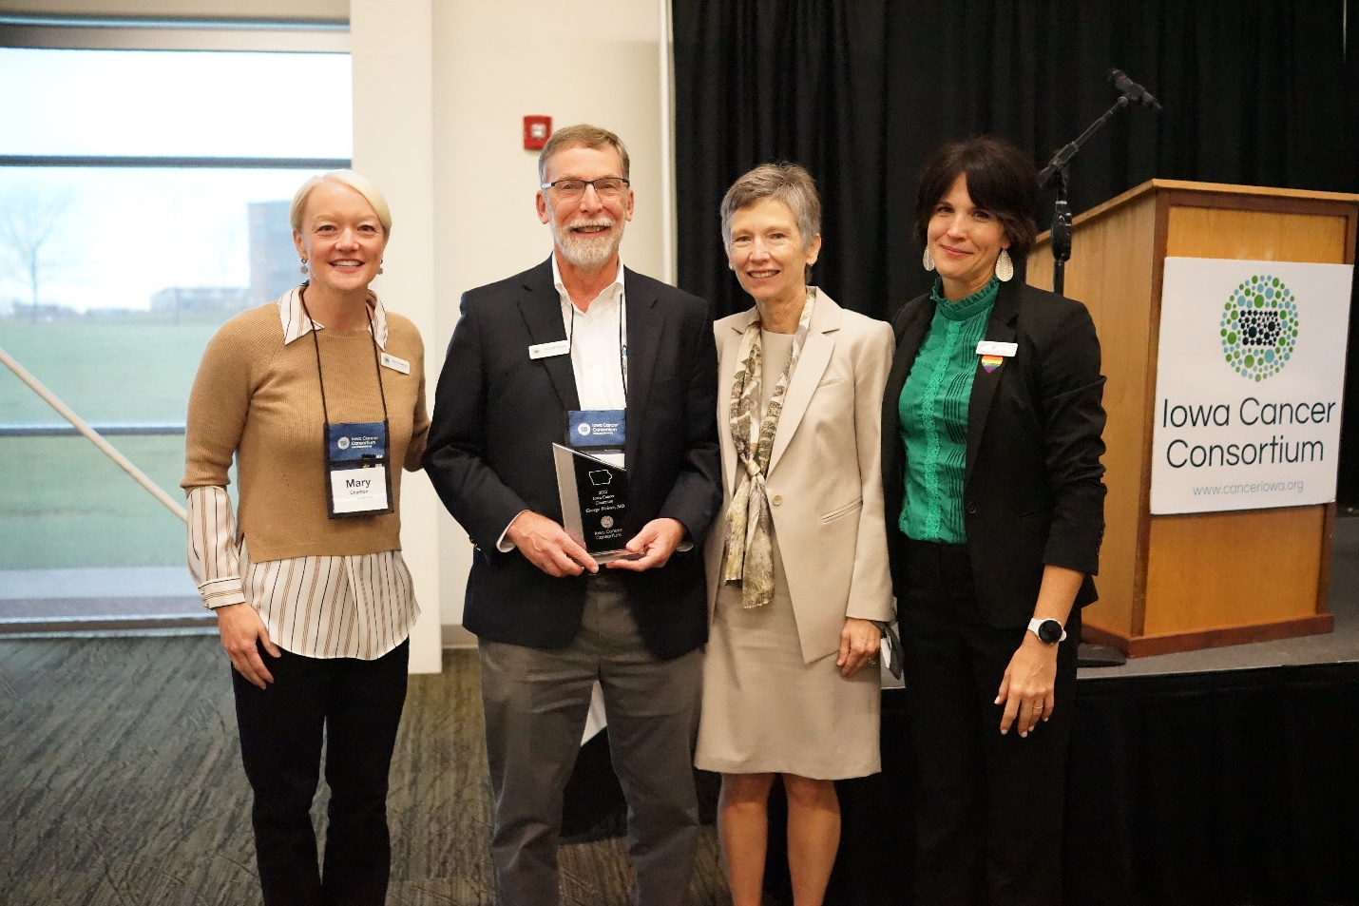
Dr. George Weiner accepts the Iowa Cancer Champion Award at the 2022 Iowa Cancer Summit. L-R: Dr. Mary Charlton (Iowa City), Dr. George Weiner (Iowa City), Dr. Teresa Weiner (Iowa City), and Kelly Wells Sittig (North Liberty).

Dr. George Weiner, namesake of the Cancer Control Visionary Award, longtime friend of Mrs. Ruedy’s, and director of the University of Iowa Holden Comprehensive Cancer Center, received the Iowa Cancer Champion Award for his decades-long contribution to cancer research and control in Iowa, including 20 years of service as president of the Iowa Cancer Consortium.

“There is no one in the state of Iowa who has done more to elevate cancer care in Iowa than Dr. Weiner” said Dr. Richard Deming, medical director of the MercyOne Richard Deming Cancer Center and vice president of the Iowa Cancer Consortium.

“For the past 20 years, Dr. Weiner has played an integral role in the creation and growth of the Iowa Cancer Consortium which now includes over 500 individuals and organizations working together to reduce the burden of cancer in Iowa,” said Dr. Mary Charlton, director of the Iowa Cancer Registry and current president of the Iowa Cancer Consortium. “He also led the Holden Comprehensive Cancer Center in becoming a National Cancer Institute (NCI) Designated Comprehensive Cancer Center in 2000, an important status which brings substantial cancer research funds and infrastructure to Iowa.”

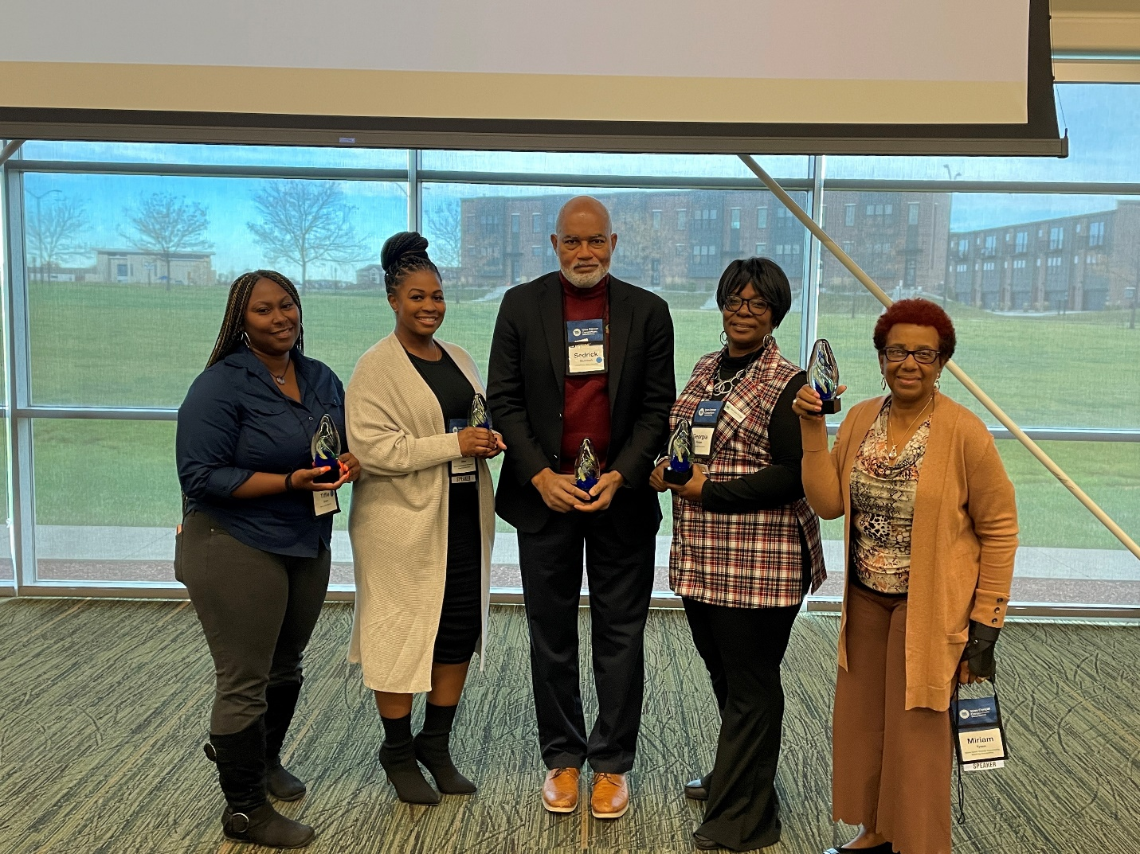
Members of the Black Hawk County Community Steering Committee accept the Spirit of Collaboration Award at the 2022 Iowa Cancer Summit. L-R: Tiffie Greer (Waterloo), Lischelle Oliver (Waterloo), Sedrick McIntosh (Waterloo), Georgia Hodge (Cedar Falls), and Dr. Miriam Brown Tyson (Waterloo). Not pictured: Angela Vanarsdale, Cathy Ketton, Lisa Ambrose, and Bridget Saffold, all of Waterloo.

A community group that came together because of the Holden Comprehensive Cancer Center and the Iowa Cancer Consortium won the Spirit of Collaboration Award. Nine Iowans comprise the Black Hawk County Community Steering Committee – a group that focuses on reducing cancer health disparities in the Black/African American community in Black Hawk County, Iowa.

This group, represented at the Iowa Cancer Summit by members Tiffie Greer, Lischelle Oliver, Sedrick McIntosh, Georgia Hodge, and Dr. Miriam Brown Tyson, is working to spread awareness about high incidence and mortality rates of prostate cancer among Black men in Iowa. Their work was featured in a “Stories from the Iowa Cancer Plan” video, which premiered at the Iowa Cancer Summit and can be viewed online.

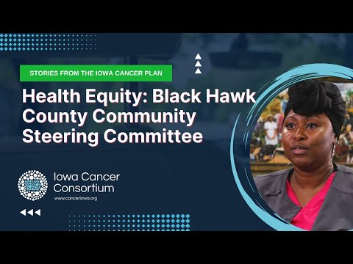
https://youtu.be/5P9S2zlI9M8

Speaking of the Black Hawk County Community Steering Committee, Dr. Natoshia Askelson of the University of Iowa said, “They are eager to continue to build relationships and sincerely recognize that collaboration is key to tackle health disparities in our state.”

The Iowa Cancer Consortium is Iowa’s statewide comprehensive cancer coalition. As a leader in cancer control, the Iowa Cancer Consortium offers the state’s cancer stakeholders access to resources, expertise, and non-competitive collaboration across traditional boundaries for a bigger impact in cancer prevention, early detection, treatment, quality of life, and health equity.

The Iowa Cancer Summit is Iowa’s only conference dedicated to comprehensive cancer control.

