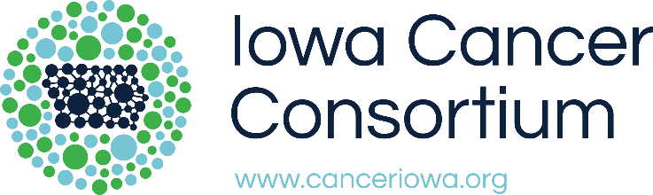
Final Report
2022 Sun-Safety Community Project
Report Checklist
☐ Final Report (below) is complete and emailed to orton@canceriowa.org by September 16, 2022.
☐ Event Materials (meeting minutes, agendas, promotional pieces, evaluation materials, etc.) are attached to this document or emailed to orton@canceriowa.org.
☐ At least Three (3) Photos documenting the project are attached or emailed to orton@canceriowa.org. The Iowa Cancer Consortium reserves the right to use these pictures in publications and marketing materials. Awardees must obtain appropriate consent for all pictures for use by both the grantee organization and the Iowa Cancer Consortium. All pictures are to be submitted electronically in JPEG format with people and places identified.

Project Information
Project Title: | Click or tap here to enter text.
Project Chair: | Click or tap here to enter text.
Total number of Iowans reached to date: | Click or tap here to enter text.
Counties impacted by project to date: | Click or tap here to enter text.
Please provide an overview of project outcomes:
Click or tap here to enter text.

How have you collaborated with other organizations on this project?
Click or tap here to enter text.

Please describe any factors that have contributed to project success:
Click or tap here to enter text.

Please describe any barriers or issues affecting the success of the project to date:
Click or tap here to enter text.

Please describe any unanticipated outcomes to date resulting from your project:
Click or tap here to enter text.

Please report any future plans for sun-safety projects in your community or sustainability of the current project:
Click or tap here to enter text.

Did you utilize the Ray and the Sunbeatables™ Curriculum? If so, please briefly explain how it was used and the outcomes:
Click or tap here to enter text.

